CustomRandomWalk without HappyFlow

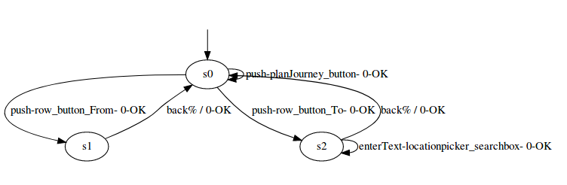

CustomRandomWalk with HappyFlow

